Manchester
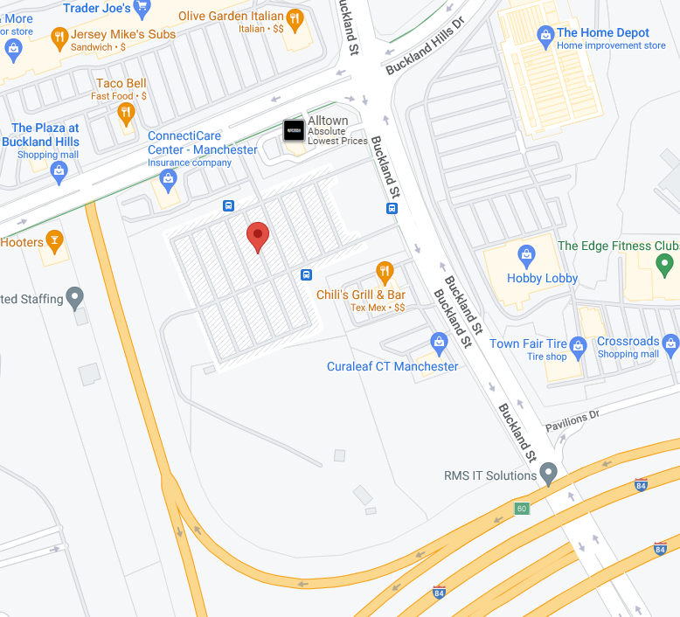
Manchester Park & Ride
1515 Pleasant Valley Road, Manchester, CT
Please park in the corner of the lot closest to the Connecticare Building

From the West (e.g. from Farmington)
I-84 East: Take Exit 62. Turn left onto Buckland St. After 2nd light turn left in the Park & Ride Commuter Lot just past the Chili’s Restaurant.
From the East (e.g. from Vernon)
I-84 West: Take Exit 62. Turn right onto Pleasant Valley Rd. Turn right into Park and Ride Commuter Lot, just past the Connecticare Building.
From I-291 (e.g. from Bloomfield)
Take Exit 5 for Tolland Turnpike (“Mall” exit). Turn left onto Tolland Turnpike. Follow for just over one mile. Turn left onto Buckland St. Turn left in the Park & Ride Commuter Lot just past Chili’s Restaurant.
Farmington – New Departure Starting on August 1, 2023
Farmington Park & Ride
575 Colt Hwy (Rte 6) & South Rd, Farmington, CT
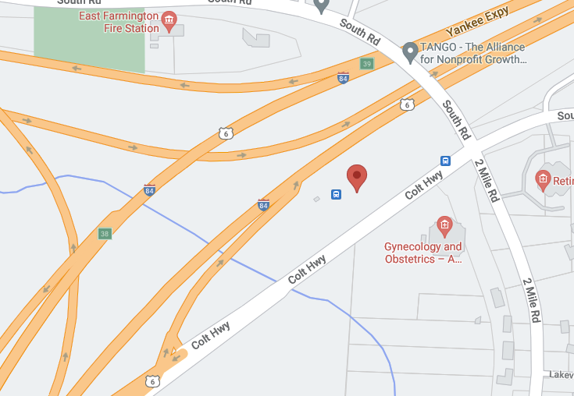
Please park in the commuter lot on the right

From the West (e.g. from Waterbury)
I-84 East: Take Exit 37 (Fienemann Rd). Use the left 2 lanes to turn left onto Fienemann Rd. Follow for approx. 1 mile and turn right onto US-6 East (Colt Hwy). Commuter lot will be on the left.

From the East (e.g. from Hartford)
I-84 West: Take Exit 38 (US-6 Bristol). Once on the exit ramp stay in left lane and turn left at the traffic light onto US-6 East. Continue straight on US-6E (Colt Hwy). Commuter lot is on the left.

From Route 9 (e.g. from Middletown)
Route 9 North: Take Exit 40A to I-84W. Follow directions above from I-84W.

Waterbury
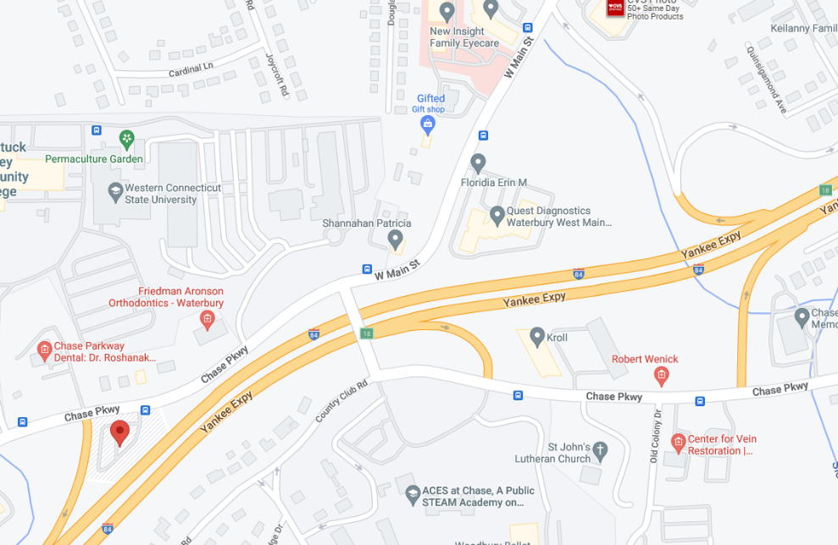
Chase Parkway Park & Ride
709 Chase Parkway, Waterbury CT (I-84, Exit 18)

From the East (e.g. Southington)
I-84 W: Take exit 18. Turn left onto West Main Street. Continue straight onto Chase Parkway. Turn left into Park and Ride lot.
From the West (e.g. Middlebury)
I-84 E: Take exit 18. Turn right onto Chase Parkway. Take 1st right to stay on Chase Pkwy. Turn left to stay on Chase Pkwy. Turn left into Park and Ride lot.
From Route 8 North or South
Take Exit 33 for I-84 W. Follow “from the East” directions above.
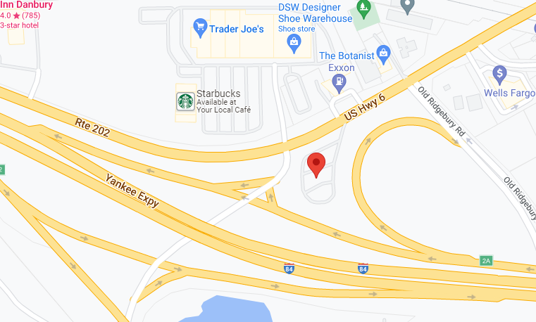
Danbury
Commuter Park and Ride – Exit 2,
114 Mill Plain Rd, Danbury CT (I-84 Exit 2)

From the East (e.g. Newtown)
I-84 W: Take exit 2A-2B. Take exit 2B on left. Turn right onto Woodland Rd. Take immediate right into Park and Ride lot.
From the West (e.g. New York State)
I-84 E: Take exit 2. Turn left onto Woodland Rd. Take immediate right into Park and Ride lot.
West Springfield, MA
Quality Inn, 1150 Riverdale St, West Springfield, MA

From I-91, take exit 10B (old exit 13B) to on to Rte 5 South (Riverdale St). Stay in the right Lane. Riverdale Street Quality Inn is on your right. Please park in the back of the hotel parking lot.

